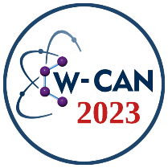 | World Congress on Applied Nanotechnology  W-CAN 2023  October 25-27, 2023  : | 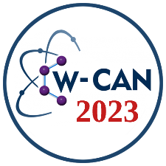

FullText / Abstract

Title of the research
Author Name SURNAME ¹, Author Name SURNAME ^{1,2*} (Please add ORCID link for authors in )
¹ Department of Xyz, Xyz Faculty, Xyz University, City, Country.
² Department of Xyz, Xyz Faculty, Xyz University, City, Country.
*Corresponding author E-mail: e-mail@xyz.edu

Highlights
- Highlights of the research -1. (use minimum 2 highlights)
- Highlights of the research -2.
- Highlights of the research -3.
- Highlights of the research -4.

Keywords

Keyword-1 (use minimum 2)
Keyword-2
Keyword-3
Keyword-4
Keyword-5
Keyword-6
Abstract
Only use this page for abstract. Abstracts should not be more than one page.
The subject and problem, the purpose and importance of the research, the methods used in the research, the data collection techniques, and the findings should be mentioned in each abstract.
Fulltext is limited to minimum 3 pages and maximum 4 pages.

Introduction
The introduction should clearly describe the background of the subject, and purpose [1].

Experimental
Add experimental details of your work [2].

Sub-level heading can be used
Add sub-level details of your work if needed.

Results and Discussion
This section may include results and discussion. Figures must be addressed inside the text.
Equations must be addressed in the text.

$L=\frac{0.9λ}{Bcosθ}$ (1)

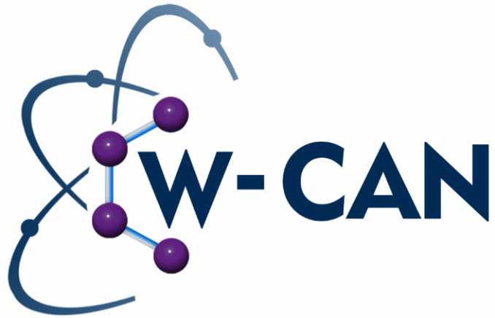
Figure 1. W-CAN logo
Table contents must be addressed in the text.

Table 1. Particle sizes calculated from the Scherer equation
Name | Size (nm)
A | 1.1
B | 1.2
C | 1.3
D | 1.4
E | 1.5

Conclusion
Conclusion of the work must be presented.

Acknowledgment
Acknowledgments must be given in this section.

References
1. Antolini, E. Carbon supports for low-temperature fuel cell catalysts. Appl. Catal. B Environ. 2009, 88, 1–24, doi:10.1016/j.apcatb.2008.09.030.
2. Caglar, A.; Cogenli, M.S.; Yurtcan, A.B.; Kivrak, H. Effective carbon nanotube supported metal (M=Au, Ag, Co, Mn, Ni, V, Zn) core Pd shell bimetallic anode catalysts for formic acid fuel cells. Renew. Energy 2020, 150, 78–90, doi:10.1016/j.renene.2019.12.104.
3. Çögenli, M.S.; Ayşe, B.Y. Graphene aerogel supported platinum nanoparticles for formic acid electro-oxidation. Mater. Res. Express 2018, 5, 075513, doi:10.1088/2053-1591/aad0e8.

